A1606-ME-Lebanon-Ba’albek-Male Sitting–Diagonal Bib-Feet unpegged-200 BCE

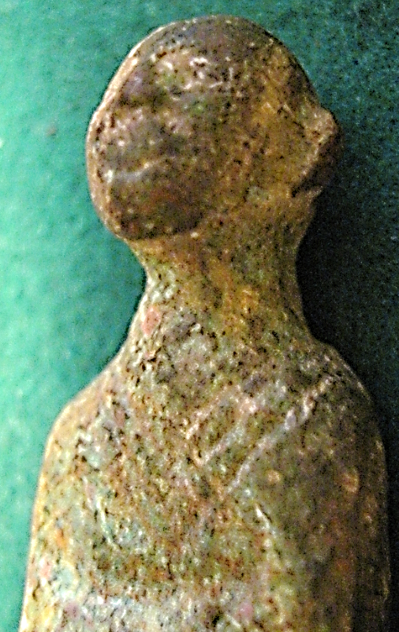 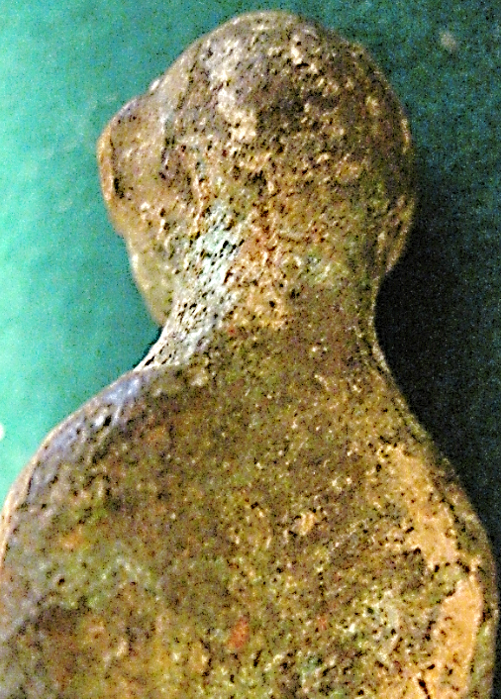

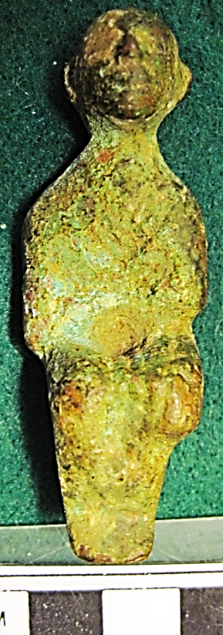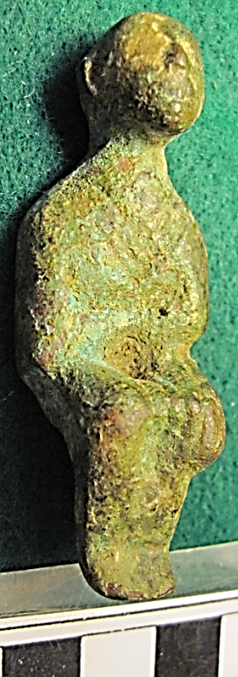

Figs. 1-4. Lebanon-Ba’albek-Male Sitting– Diagonal Bib-Feet unpegged-200 BCE

**Case no.: 3**

**Accession Number: A1606**

**Formal Label:** Lebanon-Ba’albek-Male Sitting–Diagonal Bib-Feet unpegged-200 BCE

**Display Description:**

This bronze male figurine, whose head has closely cropped hair, suggests that originally a headdress covered his head. This is because he has an ornate, diagonal bib with a distinctive linear pattern suggesting a gold brocade covering his chest and his back. This suggests that he is a highly revered personage or a deity. The arms of this figure are held at the waist and the legs are closely spaced. The feet have no pegs for attachment to a plinth. So this was a moveable figurine. It is suggested that this bronze figurine might be adon, one of the Heliopolitan triad’s progeny: the son of god (Baʿal), his consort (Ashtart).

**LC Classification:** DS99.B2

**Date or Time Horizon:** 200 BCE

**Geographical Area:** Ba’albek, Lebanon

**Map:**

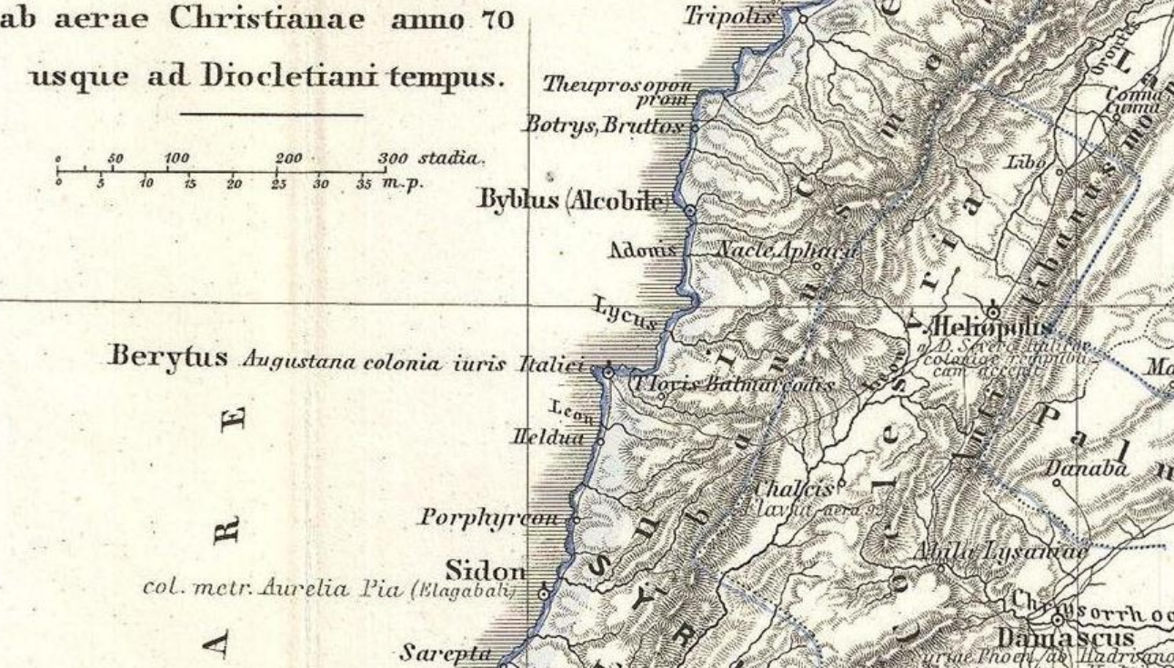

Map showing the location of Ba’albek ca. 70 CE. From <https://upload.wikimedia.org/wikipedia/commons/e/e9/1865_Spruner_Map_Israel_or_Palestine_post_70_AD.jpg>

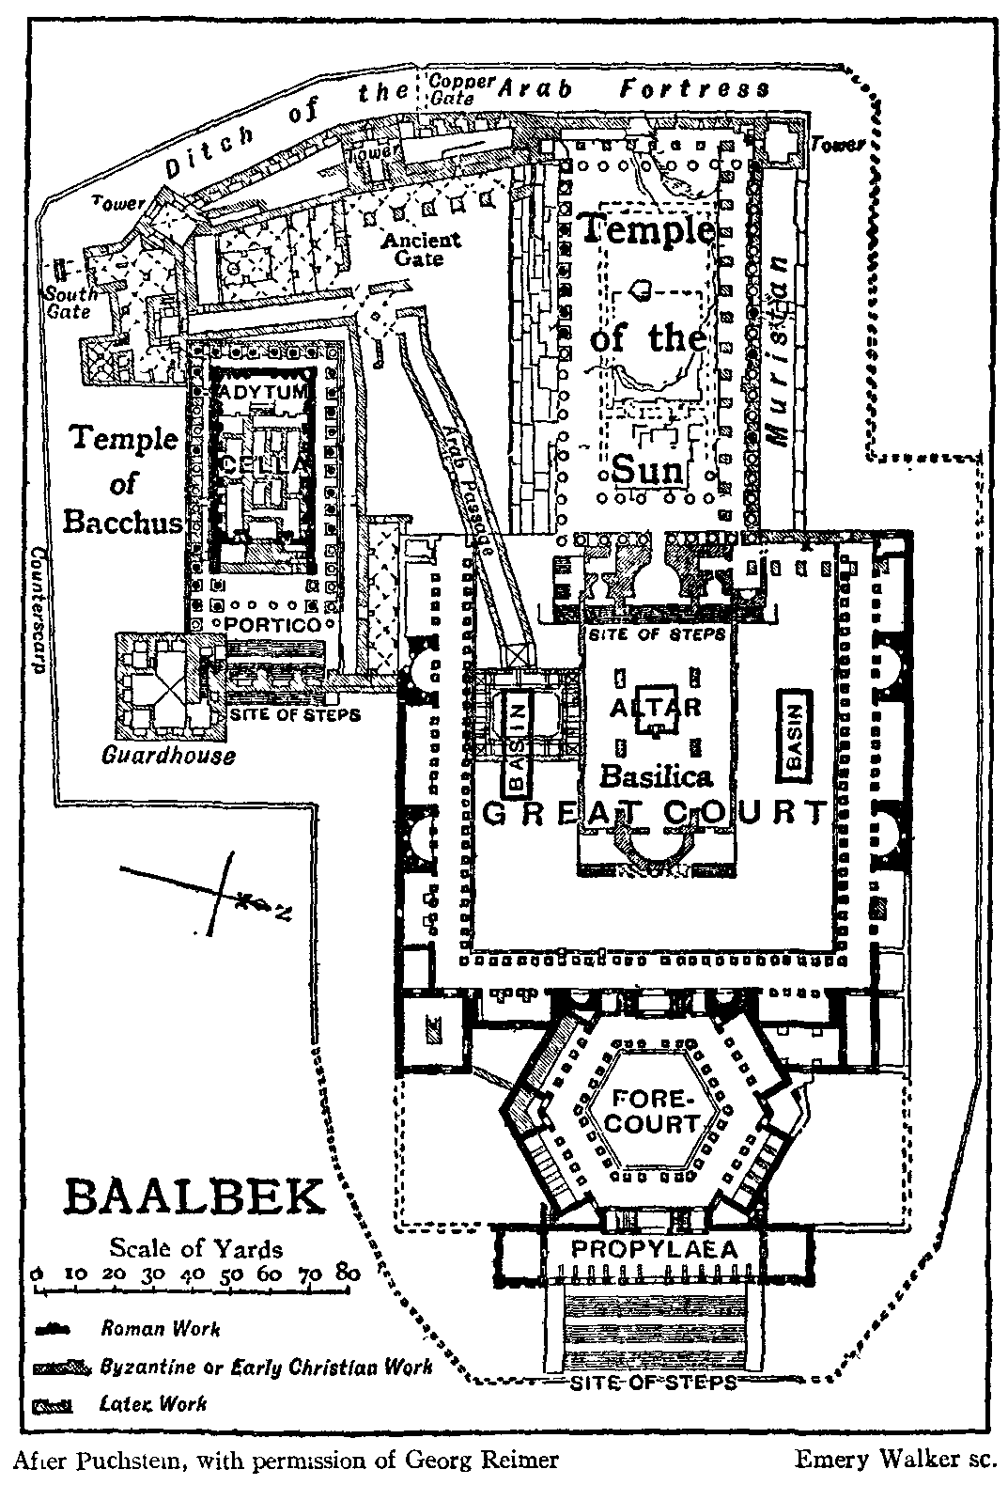

A 1911 diagram of the Baalbek ruins after **Otto Puchstein’s** excavations (**Puchstein** 1905) ("Führer durch die Ruinen von Baalbek". 39 S., G. Reimer, Berlin 1905, from the Encyclopaedia Britannica, 1911: 90. (Facing SW, with the Temple of Jupiter labelled "Temple of the Sun").

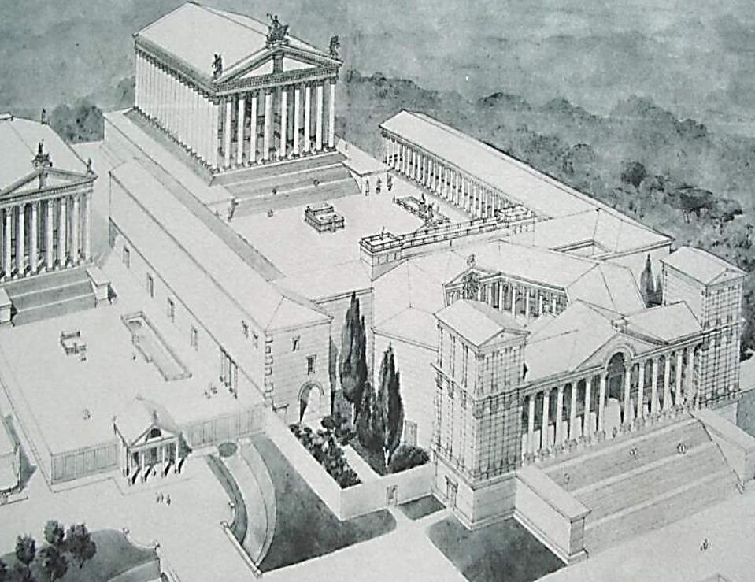

A proposed reconstruction of the temple complex at Baalbek under the <Romans>. From <http://en.wikipedia.org/wiki/Image:Baalbek-Layout.jpg>

**GPS coordinates:** [34°0′22.81″N 36°12′26.36″E](https://tools.wmflabs.org/geohack/geohack.php?pagename=Baalbek&params=34_0_22.81_N_36_12_26.36_E_region:LB_type:city(82608))

**Cultural Affiliation:** Canaanite

**Medium:** bronze

**Dimensions: 64.19 mm, 2.527 in**

**Weight: 70 g, 2.5 oz.**

**Condition: original**

**Provenance:** This bronze figurine is similar to the female bronze figurine that was acquired by the Ashmolean Museum in 1888 (Oxford acc. No. 1889: 807). See Harden 1962: 313, pl. 83; Moscati 1970: 53, pl. 45.

**Discussion:**

During the Canaanite period, the local temples were largely devoted to the Heliopolitan Triad: a male god ([Baʿal](https://en.wikipedia.org/wiki/Ba%CA%BFal" \o "Baʿal)), his consort ([Ashtart](https://en.wikipedia.org/wiki/Ashtart" \o "Ashtart)), and their son, Adon[is] (Jidejian 1975: 47) The [Levantine](https://en.wikipedia.org/wiki/Levant) ("lord") [Adonis](https://en.wikipedia.org/wiki/Adonis), who was drawn into the Greek pantheon, was considered by [Joseph Campbell](https://en.wikipedia.org/wiki/Joseph_Campbell) (1962: 39-40) among others to be another counterpart of Tammuz, "the dead and resurrected god Tammuz (Sumerian Dumuzi), prototype of the Classical Adonis, who was the consort as well as son by virgin birth, of the goddess-mother of many names: Inanna, Ninhursag, Ishtar, Astarte, Artemis, Demeter, Aphrodite, Venus.” The Aramaic name “Tammuz” was probably from the Sumerian Damu-zid that became Dumuzi in Akkadian.

The site of the present Temple was the focus of earlier worship of Ba’al, as its altar was positioned at the very summit of the hill and fill was brought in to level this summit location for additional buldings. The Romans appreciated the structure of the Ba’al temple on this summit and reasoned that Ba’al, being the highest deity of the Heoliopolis, was parallel to their Jupite, the highest deity of the Roman Heliopolis, so Ba’al’s temple location should emulate that of Jupiter’s as well. Jupiter was, of course, parallel to the Greek Zeus so that the Roman Heliopolis was dedicated to the cult of Ba’al-Jupiter-Zeus. The nomenclature, however, favored Zeus as the titular deity, so that the main building in the huge “Sanctuary” was the temple complex of “Zeus”.

**References:**

[Campbell, Joseph](https://en.wikipedia.org/wiki/Joseph_Campbell), 1962, *Oriental Mythology: The Masks of God*. New York: Viking Pengui.

Cook, Arthur Bernard. 1914. [*Zeus: A Study in Ancient Religion*](http://digi.ub.uni-heidelberg.de/diglit/cook1914bd1/0011), [*Vol. I: Zeus God of the Bright Sky*](http://digi.ub.uni-heidelberg.de/diglit/cook1914bd1/0011), [Cambridge](https://en.wikipedia.org/wiki/Cambridge,_England): Cambridge University Press*.*

Harden, D. 1962. *The Phoenicians*. London: Harmondsworth, Penguin Books.

Jidejian, Nina. 1975. Baalbek: Heliopolis: ‘City of the Sun.’ Beirut: Dar el-Machreq Publishers,

Moscati, S. 1970. The world of the Phoenicians. London: London Weidenfeld & Nicolson.

Negbi, Ora. 1976. Canaanite Gods in Metal: an archaeological study of ancient Syro-Palestinian Figurines. Tel Aviv: Tel Aviv University, Institute of Archaeology.

Puchstein, Otto.1905. *Führer durch die Ruinen von Baalbek*. Berlin: G. Reimer.